Clothes Shop Management System
A Presentation Document

1. Introduction
This presentation document summarizes the Clothes Shop Management System. It includes the customer questionnaire form, the product records form, and the general system workflow. The goal of the system is to collect customer preferences and store clothing item details efficiently.

2. Customer Questionnaire Form
The Questionnaire Form is designed to collect customer information, such as name, gender, age group, preferred clothing style, favorite color, and any additional suggestions. This helps the clothes shop understand customer needs and trends.

Form Screenshot Placeholder
📌 (Insert Questionnaire Screenshot Here)

HTML Code Included in System
<!DOCTYPE html>
<html lang="en">
<head>
<meta charset="UTF-8">
<title>Clothes Shop Questionnaire</title>
<style>
body {
background: linear-gradient(135deg, #f8ffae 0%, #43c6ac 100%);
font-family: 'Segoe UI', Arial, sans-serif;
margin: 0;
padding: 0;
min-height: 100vh;
display: flex;
align-items: center;
justify-content: center;
}
.questionnaire {
background: #fff;
border-radius: 16px;
box-shadow: 0 4px 24px rgba(67,198,172,0.2);
padding: 32px 40px;
max-width: 400px;
width: 100%;
}
.questionnaire h2 {
color: #43c6ac;
margin-bottom: 20px;
text-align: center;
}
label {
display: block;
margin: 16px 0 6px 0;
color: #333;
font-weight: 500;
}
input, select, textarea {
width: 100%;
padding: 8px 10px;
border: 1px solid #43c6ac;
border-radius: 6px;
margin-bottom: 12px;
font-size: 1em;
background: #f8ffae;
transition: border 0.2s;
}
input:focus, select:focus, textarea:focus {
border: 2px solid #43c6ac;
outline: none;
}
button {
background: linear-gradient(90deg, #43c6ac 0%, #f8ffae 100%);
color: #222;
border: none;
border-radius: 6px;
padding: 10px 0;
width: 100%;
font-size: 1.1em;
font-weight: bold;
cursor: pointer;
transition: background 0.2s;
}
button:hover {
background: linear-gradient(90deg, #f8ffae 0%, #43c6ac 100%);
}
</style>
</head>
<body>
<form class="questionnaire" action="save_questionnaire.php" method="POST">
<form class="questionnaire">
<h2>Clothes Shop Questionnaire</h2>
<label for="name">Your Name</label>
<input type="text" id="name" name="name" required>
<label for="gender">Gender</label>
<select id="gender" name="gender" required>
<option value="">Select...</option>
<option>Female</option>
<option>Male</option>
<option>Other</option>
<option>Prefer not to say</option>
</select>
<label for="age">Age Group</label>
<select id="age" name="age" required>
<option value="">Select...</option>
<option>Under 18</option>
<option>18-25</option>
<option>26-40</option>
<option>41-60</option>
<option>60+</option>
</select>
<label for="style">Preferred Clothing Style</label>
<select id="style" name="style" required>
<option value="">Select...</option>
<option>Casual</option>
<option>Formal</option>
<option>Sportswear</option>
<option>Traditional</option>
<option>Trendy</option>
</select>
<label for="color">Favorite Color</label>
<input type="text" id="color" name="color">
<label for="feedback">Any Suggestions?</label>
<textarea id="feedback" name="feedback" rows="3"></textarea>
<button type="submit">Submit</button>
</form>
</body>
</html>
SCREENSHOT
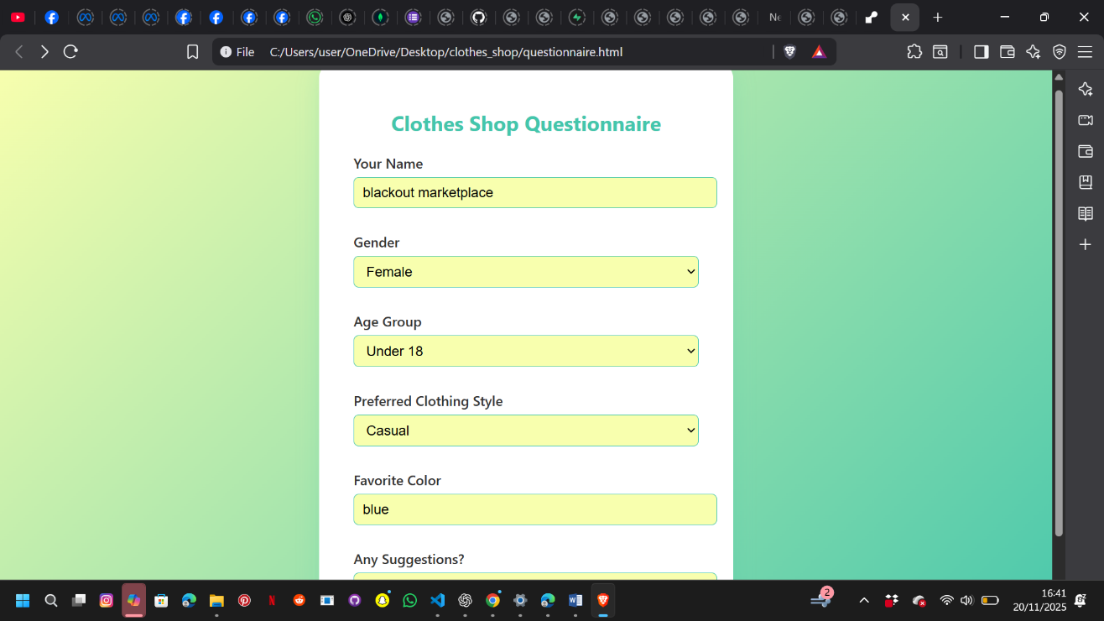

3. Clothing Records Form
The Records Form allows the shop staff to add new clothing items, including item name, category, size, color, quantity, and price. This supports inventory tracking and ensures proper stock management.

Form Screenshot Placeholder
📌 (Insert Records Screenshot Here)

HTML Code Included in System
<!DOCTYPE html>
<html lang="en">
<head>
<meta charset="UTF-8">
<title>Clothes Shop Record Form</title>
<link href="https://fonts.googleapis.com/css?family=Roboto:400,700&display=swap" rel="stylesheet">
<style>
body {
background: linear-gradient(135deg, #f8ffae 0%, #43c6ac 100%);
font-family: 'Roboto', sans-serif;
margin: 0;
padding: 0;
min-height: 100vh;
display: flex;
align-items: center;
justify-content: center;
}
.form-container {
background: #fff;
border-radius: 16px;
box-shadow: 0 8px 24px rgba(67,198,172,0.2);
padding: 32px 40px;
max-width: 400px;
width: 100%;
}
h2 {
text-align: center;
color: #43c6ac;
margin-bottom: 24px;
letter-spacing: 1px;
}
label {
display: block;
margin-bottom: 8px;
color: #333;
font-weight: 700;
}
input, select {
width: 100%;
padding: 10px 12px;
margin-bottom: 18px;
border: 1px solid #43c6ac;
border-radius: 6px;
font-size: 1em;
background: #f8ffae;
transition: border 0.2s;
}
input:focus, select:focus {
border-color: #f7971e;
outline: none;
}
button {
width: 100%;
padding: 12px;
background: linear-gradient(90deg, #43c6ac, #f7971e);
color: #fff;
border: none;
border-radius: 6px;
font-size: 1.1em;
font-weight: 700;
cursor: pointer;
transition: background 0.2s;
}
button:hover {
background: linear-gradient(90deg, #f7971e, #43c6ac);
}
</style>
</head>
<body>
<div class="form-container">
<h2>Clothes Shop Record</h2>
<form action="save_record.php" method="POST">
<form>
<label for="itemName">Item Name</label>
<input type="text" id="itemName" name="itemName" required>
<label for="category">Category</label>
<select id="category" name="category" required>
<option value="">Select Category</option>
<option value="Shirt">Shirt</option>
<option value="Trousers">Trousers</option>
<option value="Dress">Dress</option>
<option value="Jacket">Jacket</option>
<option value="Skirt">Skirt</option>
<option value="Other">Other</option>
</select>
<label for="size">Size</label>
<select id="size" name="size" required>
<option value="">Select Size</option>
<option value="XS">XS</option>
<option value="S">S</option>
<option value="M">M</option>
<option value="L">L</option>
<option value="XL">XL</option>
</select>
<label for="color">Color</label>
<input type="text" id="color" name="color" required>
<label for="quantity">Quantity</label>
<input type="number" id="quantity" name="quantity" min="1" required>
<label for="price">Price ($)</label>
<input type="number" id="price" name="price" min="0" step="0.01" required>
<button type="submit">Add Record</button>
</form>
</div>
</body>
</html>

This is but a snippet of the front end ,
I’ll update it as I move forward with the project.

